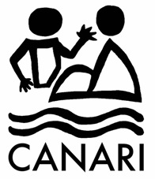

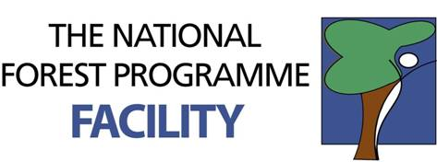
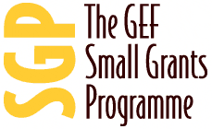

Caribbean Natural Resources Institute (CANARI)

Report of the Tobago Forest and Livelihoods Workshop

July 28th – 30th 2009
Argyle, Tobago,
Republic of Trinidad and Tobago.

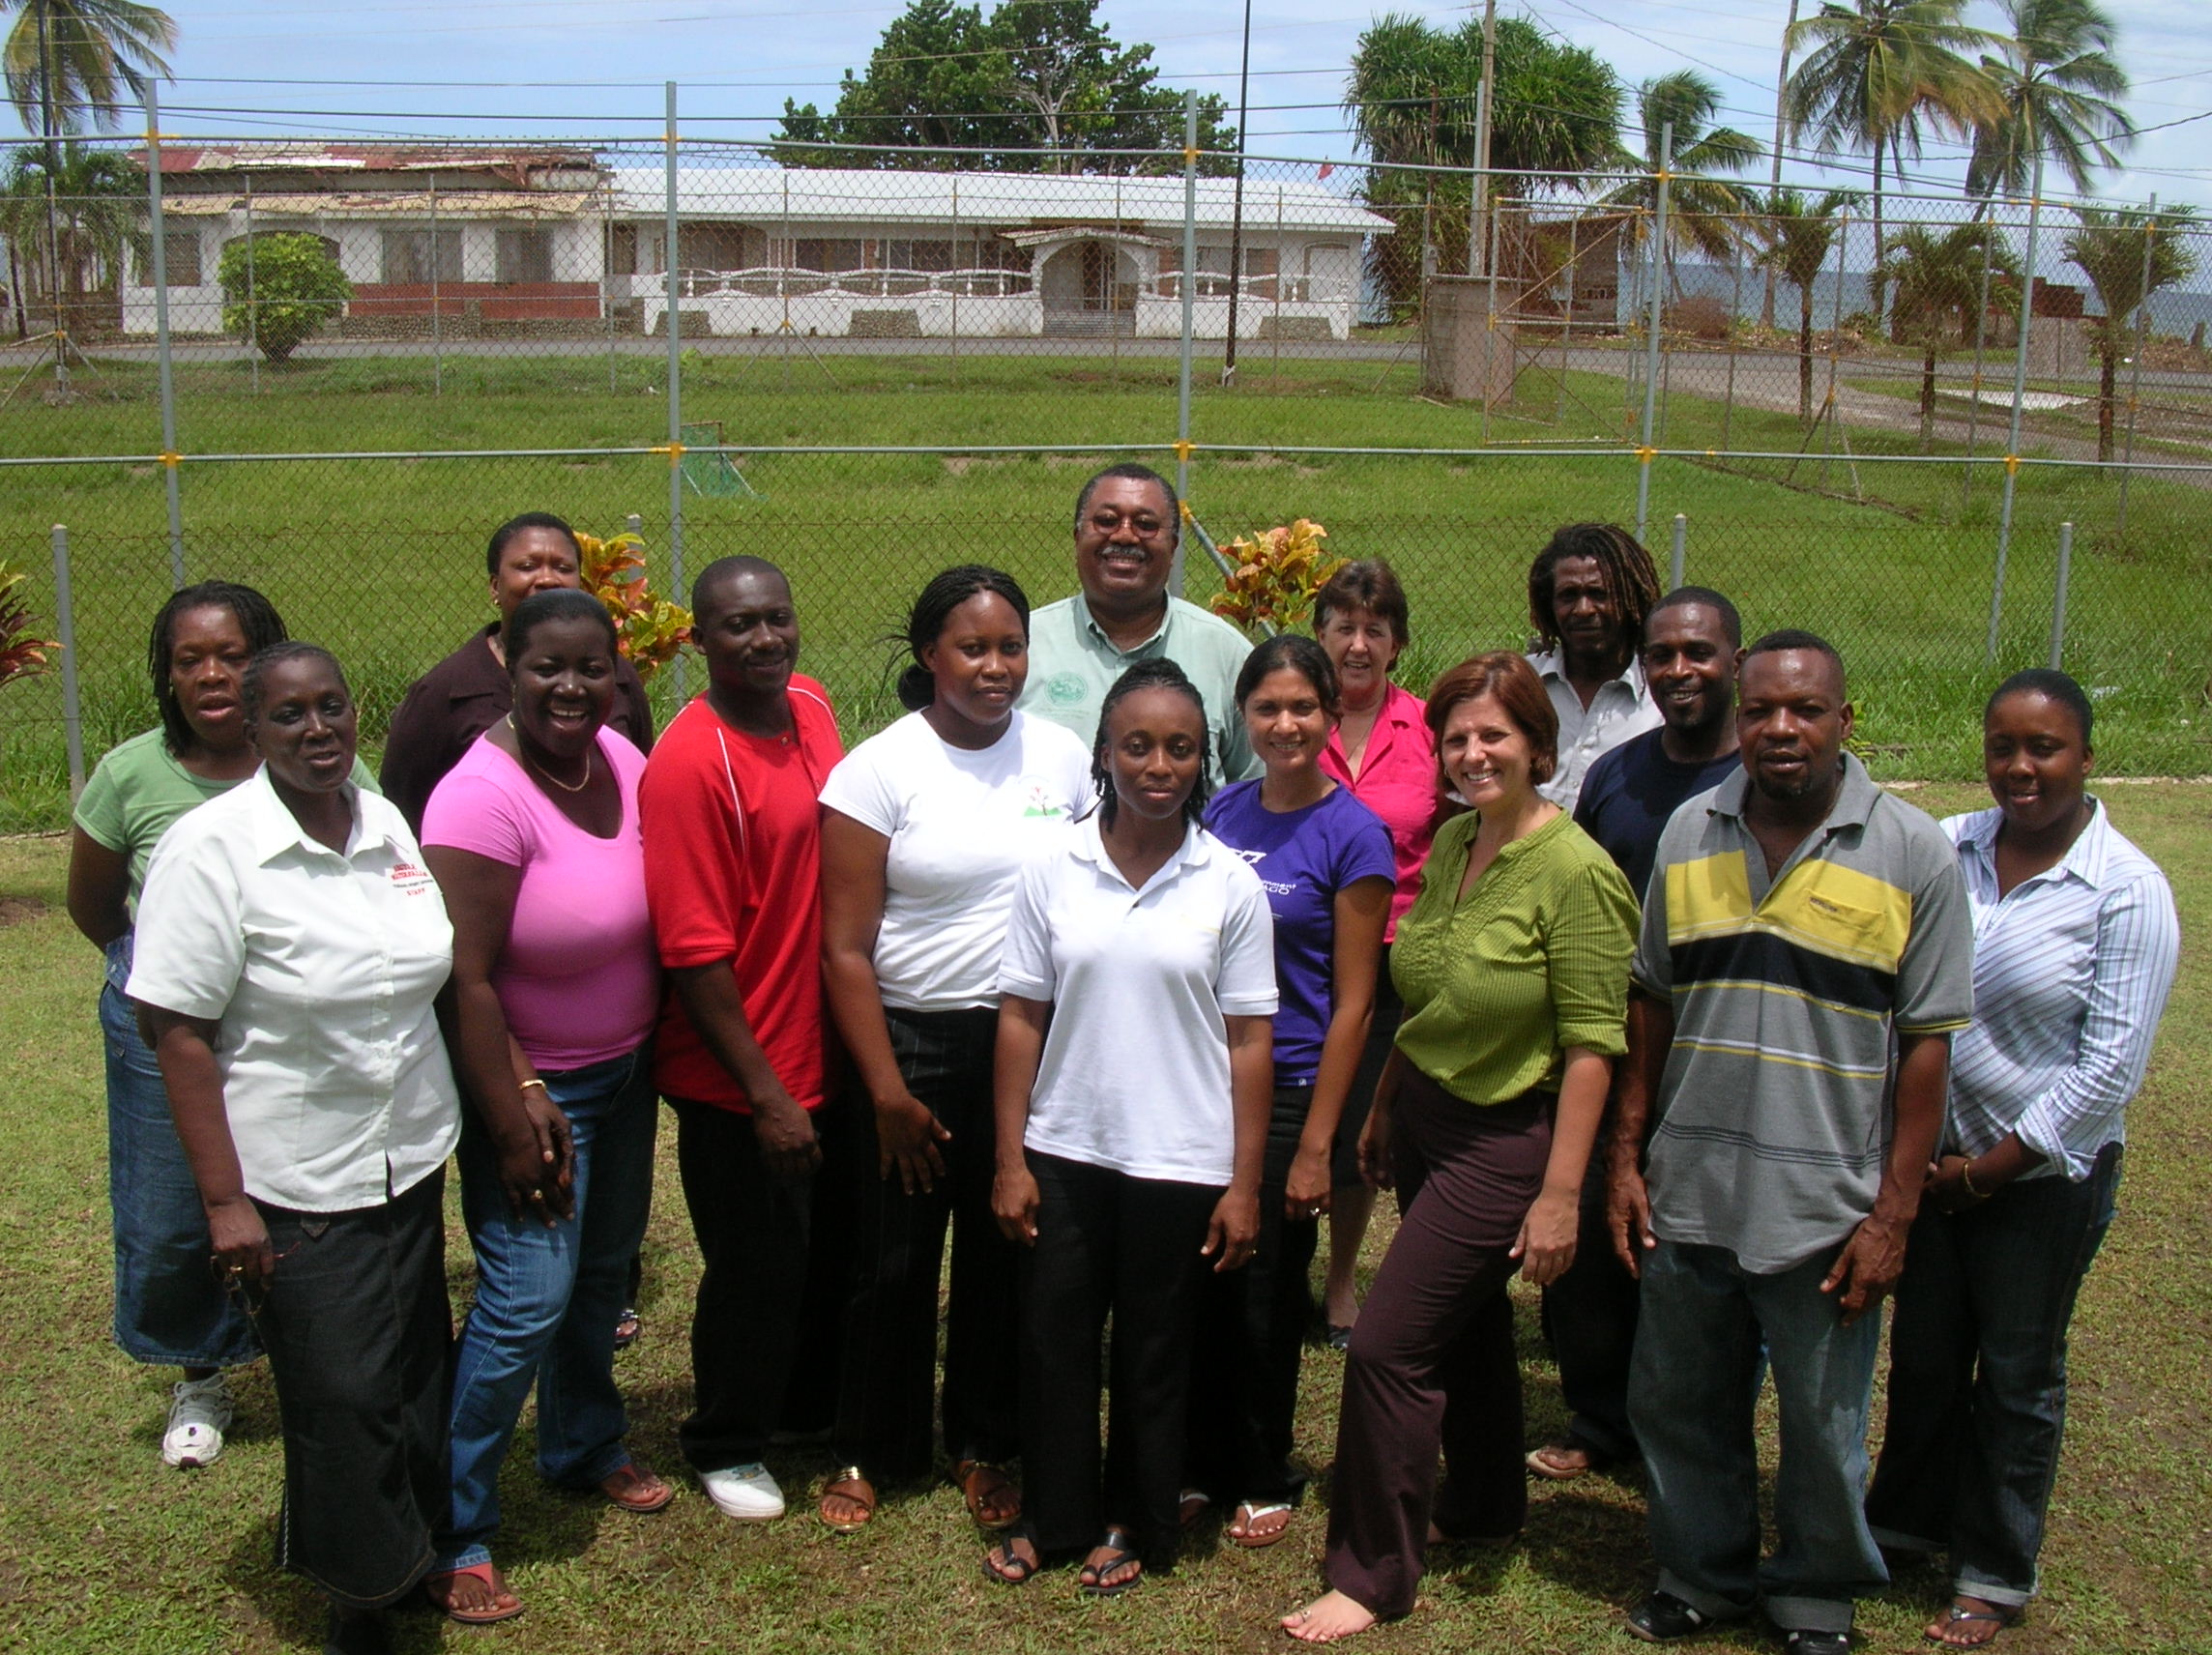

Fig1: Workshop participants at Argyle community centre, Tobago.

- Background
This workshop is part of a regional programme on Forests and Livelihoods currently being conducted in Barbados, Commonwealth of Dominica, Grenada, Jamaica, Saint Christopher (St. Kitts) & Nevis, Saint Lucia, Saint Vincent & the Grenadines, and Trinidad & Tobago under CANARI’s Forests and Livelihoods Programme.
CANARI’s Forests and Livelihoods Programme seeks to enhance the contribution of forest goods and ecological services to sustainable livelihoods of the rural poor in the islands of the Caribbean. The programme encompasses research and analysis as well as building capacity at local, national and regional level for equitable participation and effective collaboration of stakeholders in the management of forest resources.
- Funding
The workshop was funded by a grant from the European Commission’s Programme on Tropical Forests and other Forests in Developing Countries [2007-2009].
- Participants
The workshop targeted non-governmental organisations (NGOs) and community-based organisations (CBOs) involved in the use of forest and forest products in Tobago. The list of participants is attached as Appendix 1.

- Goal/Objectives
The goal of this workshop was to build the capacity of CBOs and NGOs for participatory forest management that enhances the contribution of forests to sustainable livelihoods.
Objectives of the workshop were to:
- Build understanding and appreciation of how forests can benefit livelihoods;
- Assess relevant and feasible potential opportunities for strengthening or developing projects that can benefit livelihoods;
- Build capacity to effectively design projects on forests and livelihoods;
- Identify opportunities for funding and technical assistance for forests and livelihoods projects.

- Key Outcomes
Key outcomes of the workshop included:
  - Enhanced capacity of participants to identify and analyse the relevance and feasibility of strategic opportunities for their group to implement projects that benefit forests and livelihoods, with each CBO identifying some specific project ideas to take forward;
  - Built partnerships with other CBOs, NGOs, donors and government officials, and identification of some potential areas for collaboration;
  - Identification of potential partnerships with national and regional partners who can provide funding and technical assistance through one-on-one meetings facilitating discussion of concrete ideas;
  - Identification of relevant options for funding and assistance of their current or proposed projects, with one group submitting an application to one of the donors one month after the workshop.

- Methods
The workshop was participatory and interactive and used a combination of methods including whole group discussion, small group work, presentations and field visits to familiarize participants with key definitions and concepts, to stimulate ideas for development into projects that contribute to sustainable livelihoods and to analyse lessons from forest-based livelihoods . The programme is attached as Appendix 2, the PowerPoint presentations for all of the sessions are in Appendix 3 and the handouts are in Appendix 4.
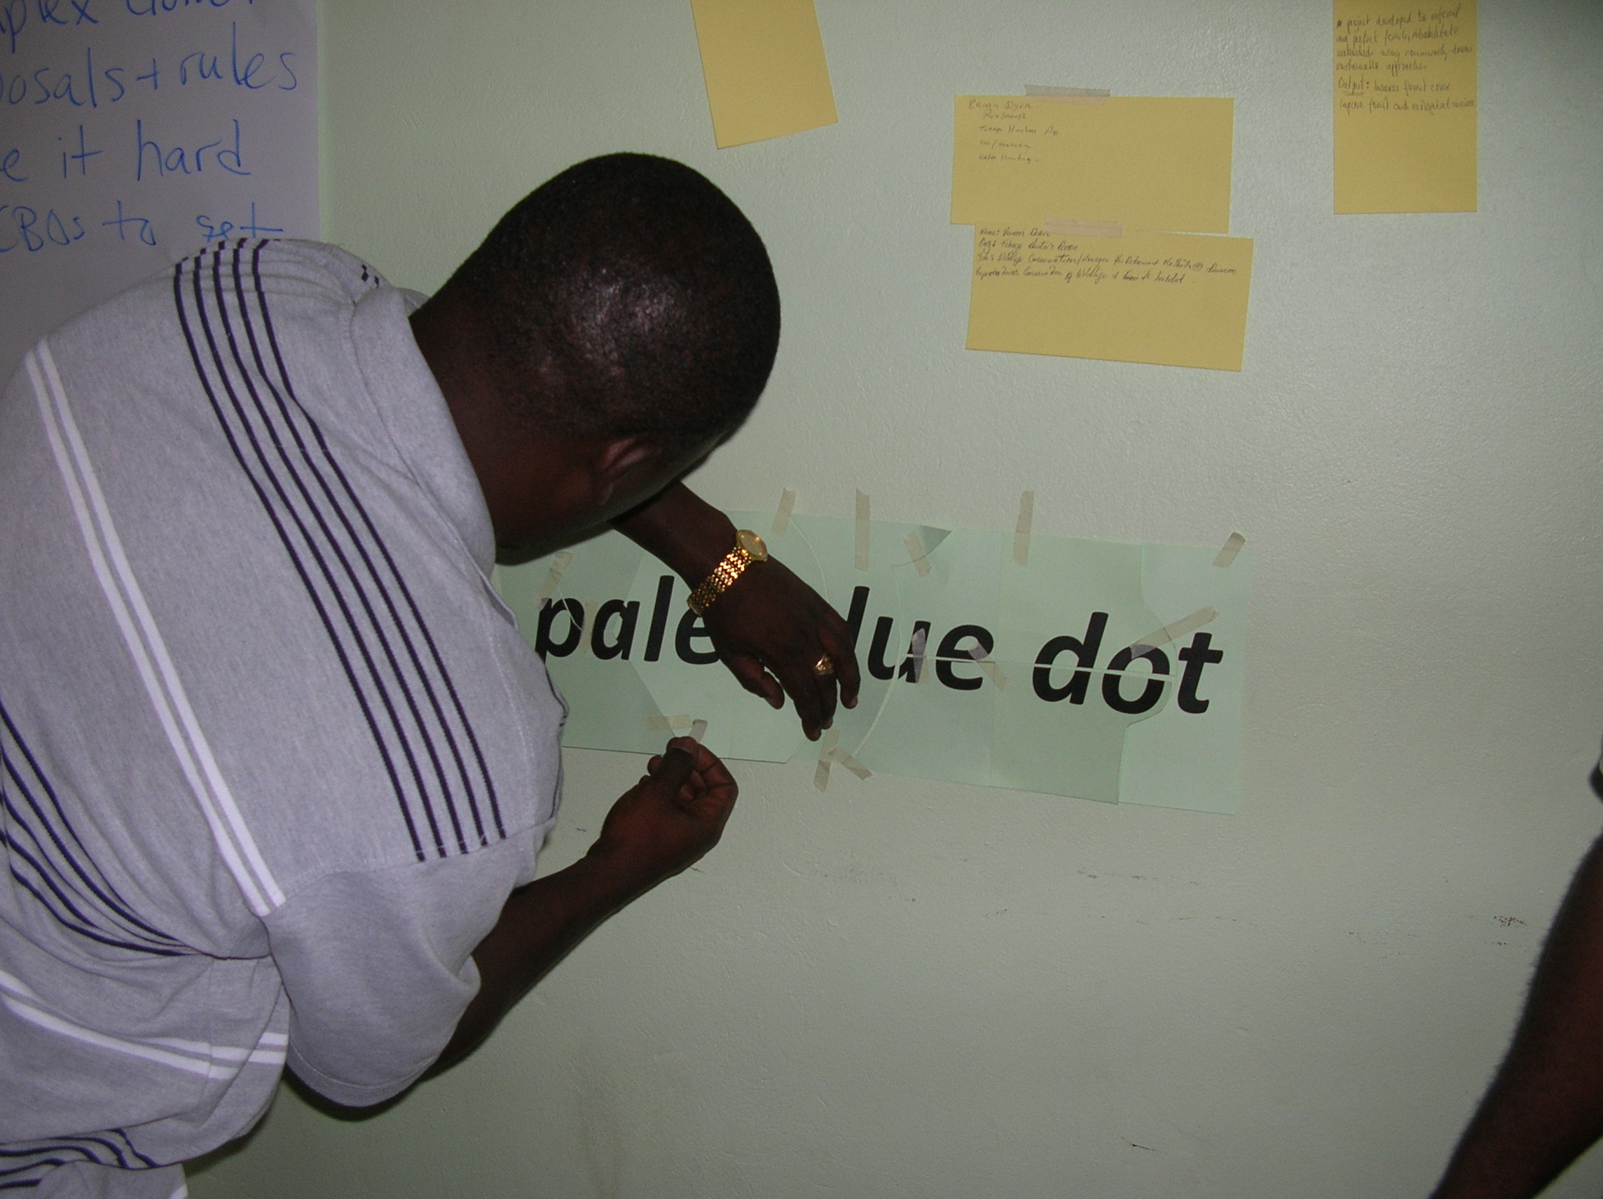

Fig2: Lanville Toppin, Roxborough Visitor Estate Cooperative, solving the puzzle.

- Lessons and recommendations

Lessons
Different users have different roles and objectives and these varying roles and objectives can lead to conflict.
Different users disseminate information differently.
Some agreements among users maybe based on trust rather than formal agreements.
There is difficulty in regulating in small, close knit communities where the violator may be a relative or friend.
The community puts pressure on its members to do the right thing.
It is hard to find the right medium to transfer information to target groups.
The choice of words is important in communicating messages.
Forest users need more than education to make a difference in the use of forest resources, they need a change in behavior.
Management works best when management is in the field often.
Management should include people in the field.
People in the field need to know that management understand and appreciate their input.
People in the field want to be part of the planning.
There are differences within communities. Stakeholders must attempt to acknowledge, learn, and in some instances tolerate, these differences in order to develop sustainable forest-based livelihoods.
Forest-based livelihood projects have the potential for developing community spirit.
Forest-based livelihoods fostered greater independence for women in the community.
There are different options (traditional e.g. churches and different mediators e.g. Secretary with responsibility for the Environment and the Member of the Parliament) available for resolving conflicts.
Ideas are hard to make into reality.
It is difficult to get to consensus.
Forest-based livelihood projects initiated through government funding require a component which prepares participants for weaning/independence.
Recommendations to the Government for the management of the Main Ridge Forest Reserve.
Use community pressure to bring about compliance.
Involve the users in management.

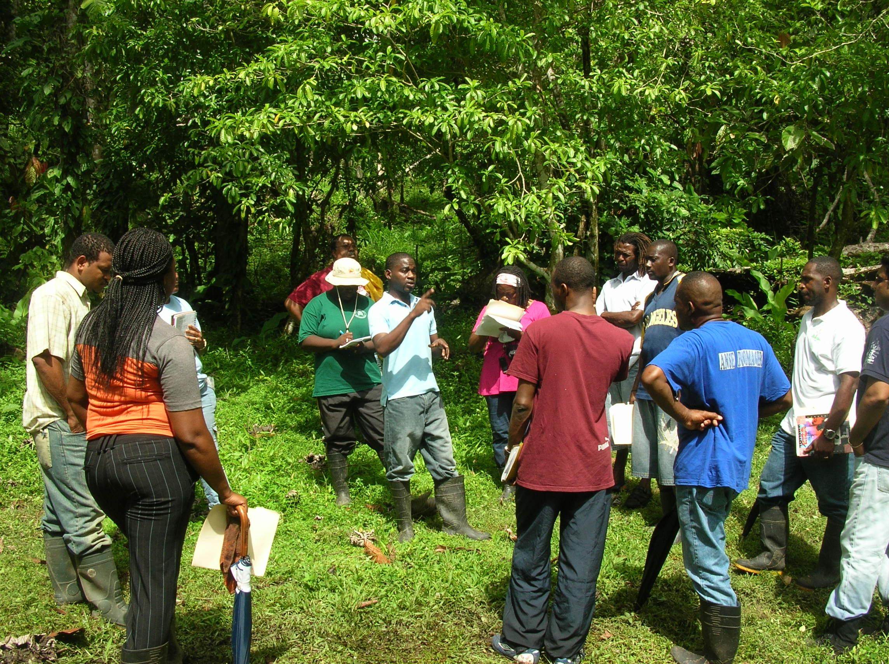

Fig 3: Workshop participants interviewing NRWRP contractor in Lure Estate, Argyle.

- Evaluation

All participants felt that the workshop was useful in providing valuable insight into sustainable forest-based livelihoods. The majority of participants identified the importance of communication, in particular networking in communities, as pivotal to ensuring a sustainable forest-based livelihood. Appendix 5 has collated comments from the evaluation forms.
9. Conclusion
The workshop was valuable as it served as a catalyst for existing groups and provided guidance for groupings to organize into profitable forest-based livelihoods. The activity also revealed a dire need for a “hand holding” / mentoring exercise to guide newly formed and inexperienced groups through the entire process of project proposal to successful project execution and finally closure.

